# Screenshots

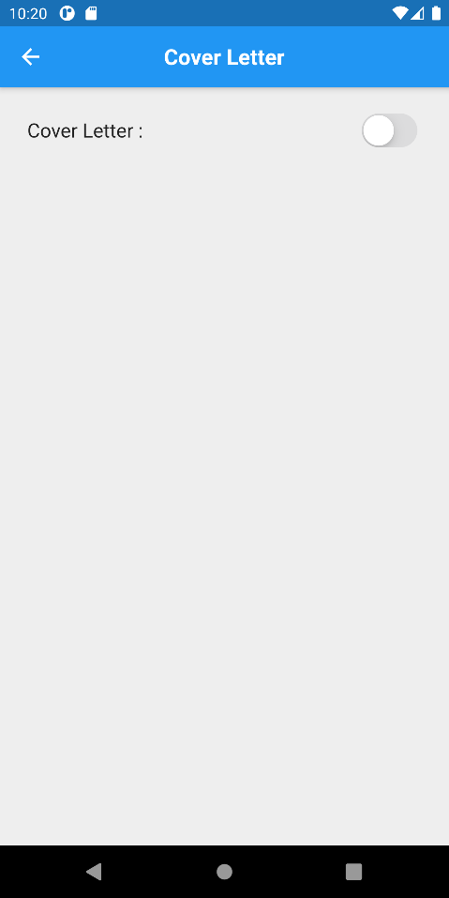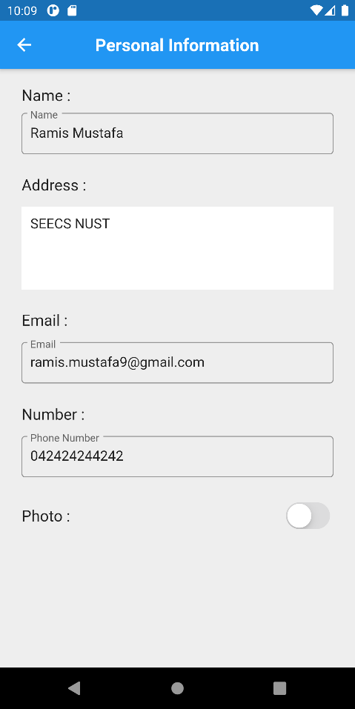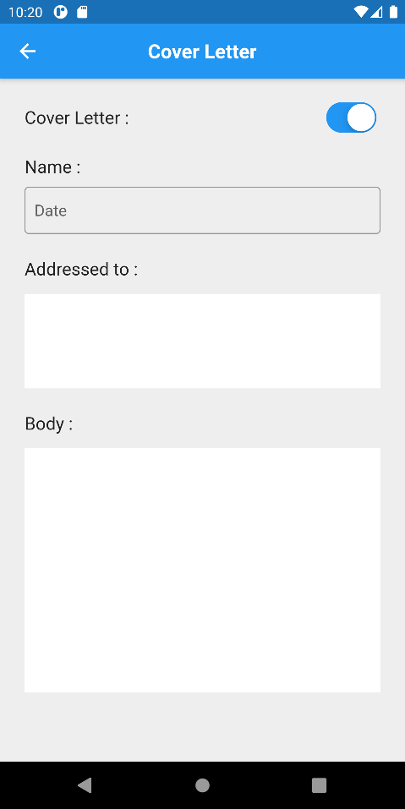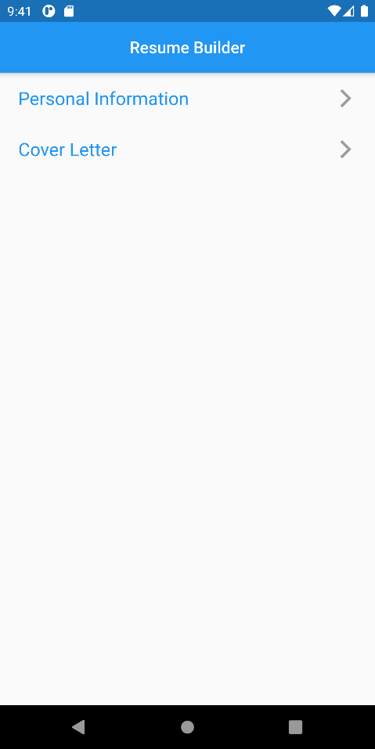

# Code

## Main.dart

import 'package:flutter/material.dart';  
import 'package:madlab6/cover_letter.dart';  
import 'package:madlab6/personal_info.dart';  
import 'package:splashscreen/splashscreen.dart';  
  
void main() {runApp(MyApp());}  
  
class MyApp extends StatelessWidget {  
 // This widget is the root of your application.  
 @override  
 Widget build(BuildContext context) {  
 return MaterialApp(  
 debugShowCheckedModeBanner: false,  
 title: 'Lab 3',  
 home: Splash()  
 );  
 }  
}  
  
class Splash extends StatelessWidget {  
 @override  
 Widget build(BuildContext context) {  
 return SplashScreen(  
 seconds: 5,  
 backgroundColor: Colors.*white*,  
 image: Image.asset('files/flutter-logo.png'),  
 loaderColor: Colors.*blue*,  
 photoSize: 150,  
 title: Text("CV Maker", style: TextStyle(fontSize: 18),),  
 navigateAfterSeconds: HomePage(),  
 );  
 }  
}  
  
class HomePage extends StatelessWidget {  
 @override  
 Widget build(BuildContext context) {  
 return Scaffold(  
 appBar: AppBar(  
 brightness: Brightness.dark,  
 centerTitle: true,  
 title: Text("Resume Builder", style: TextStyle(fontSize: 18),),  
 ),  
 body: DefaultTextStyle(  
 style: TextStyle(fontWeight: FontWeight.*bold*),  
 child: Column(  
 children: [  
 ListTile(  
 contentPadding: EdgeInsets.symmetric(horizontal: 20),  
 title: Text("Personal Information", style: TextStyle(color: Colors.*blue*, fontSize: 20),),  
 trailing: Icon(Icons.*arrow_forward_ios*, color: Colors.*grey*,),  
 onTap: (){Navigator.*of*(context).push(MaterialPageRoute(builder: (context) => PersonalInfoPage()));},  
 ),  
 ListTile(  
 contentPadding: EdgeInsets.symmetric(horizontal: 20),  
 title: Text("Cover Letter", style: TextStyle(color: Colors.*blue*, fontSize: 20),),  
 trailing: Icon(Icons.*arrow_forward_ios*, color: Colors.*grey*,),  
 onTap: (){Navigator.*of*(context).push(MaterialPageRoute(builder: (context) => CoverLetterPage()));},  
 )  
 ],  
 ),  
 ),  
 );  
 }  
}

## Personal Information

import 'package:flutter/cupertino.dart';  
import 'package:flutter/material.dart';  
  
class PersonalInfoPage extends StatefulWidget {  
 @override  
 _PersonalInfoPageState createState() => _PersonalInfoPageState();  
}  
  
class _PersonalInfoPageState extends State<PersonalInfoPage> {  
 final formKey = GlobalKey<FormState>();  
 bool switchEnabled = false;  
  
 @override  
 Widget build(BuildContext context) {  
 return Form(  
 key: formKey,  
 child: Scaffold(  
 backgroundColor: Colors.*grey*.shade200,  
 appBar: AppBar(  
 automaticallyImplyLeading: true,  
 centerTitle: true,  
 title: Text("Personal Information", style: TextStyle(fontSize: 20, fontWeight: FontWeight.*bold*),),  
 ),  
 body: SingleChildScrollView(  
 child: Padding(  
 padding: EdgeInsets.fromLTRB(25, 20, 25, 0),  
 child: Column(  
 crossAxisAlignment: CrossAxisAlignment.start,  
 children: [  
 Text("Name :", style: TextStyle(fontSize: 18),),  
 SizedBox(height: 10,),  
 TextFormField(  
 keyboardType: TextInputType.*name*,  
 decoration: InputDecoration(  
 fillColor: Colors.*transparent*,  
 border: OutlineInputBorder(),  
 labelText: "Name",  
 contentPadding: EdgeInsets.symmetric(horizontal: 10),  
 ),  
 validator: (inputVal){  
 if (inputVal.length > 0)  
 return null;  
 else  
 return "Please enter your name";  
 },  
 ),  
 SizedBox(height: 25,),  
 Text("Address :", style: TextStyle(fontSize: 18),),  
 SizedBox(height: 15,),  
 TextFormField(  
 maxLines: 4,  
 keyboardType: TextInputType.*multiline*,  
 decoration: InputDecoration(  
 border: InputBorder.*none*,  
 filled: true,  
 fillColor: Colors.*white*,  
 contentPadding: EdgeInsets.symmetric(horizontal: 10, vertical: 10)  
 ),  
 validator: (inputVal){  
 if (inputVal.length > 0)  
 return null;  
 else  
 return "Please enter your address";  
 },  
 ),  
 SizedBox(height: 25,),  
 Text("Email :", style: TextStyle(fontSize: 18),),  
 SizedBox(height: 15,),  
 TextFormField(  
 keyboardType: TextInputType.*emailAddress*,  
 decoration: InputDecoration(  
 fillColor: Colors.*transparent*,  
 border: OutlineInputBorder(),  
 labelText: "Email",  
 contentPadding: EdgeInsets.symmetric(horizontal: 10),  
 ),  
 validator: (inputVal){  
 if (inputVal.length > 0)  
 return null;  
 else  
 return "Please enter your email";  
 },  
 ),  
 SizedBox(height: 25,),  
 Text("Number :", style: TextStyle(fontSize: 18),),  
 SizedBox(height: 15,),  
 TextFormField(  
 keyboardType: TextInputType.*phone*,  
 decoration: InputDecoration(  
 fillColor: Colors.*transparent*,  
 border: OutlineInputBorder(),  
 labelText: "Phone Number",  
 contentPadding: EdgeInsets.symmetric(horizontal: 10),  
 ),  
 validator: (inputVal){  
 if (inputVal.length > 0)  
 return null;  
 else  
 return "Please enter your phone number";  
 },  
 ),  
 SizedBox(height: 25,),  
 Row(  
 mainAxisAlignment: MainAxisAlignment.spaceBetween,  
 children: [  
 Text("Photo :", style: TextStyle(fontSize: 18),),  
 CupertinoSwitch(  
 activeColor: Colors.*blue*,  
 value: switchEnabled,  
 onChanged: (active){  
 setState(() {  
 switchEnabled = active;  
 });  
 },  
 )  
 ],  
 )  
 ],  
 ),  
 ),  
 ),  
 ),  
 );  
 }  
}

## Cover letter

import 'package:flutter/cupertino.dart';  
import 'package:flutter/material.dart';  
  
class CoverLetterPage extends StatefulWidget {  
 @override  
 _CoverLetterPageState createState() => _CoverLetterPageState();  
}  
  
class _CoverLetterPageState extends State<CoverLetterPage> {  
 bool switchEnabled = false;  
 final formKey = GlobalKey<FormState>();  
  
 @override  
 Widget build(BuildContext context) {  
 return Form(  
 key: formKey,  
 child: Scaffold(  
 backgroundColor: Colors.*grey*.shade200,  
 appBar: AppBar(  
 centerTitle: true,  
 automaticallyImplyLeading: true,  
 title: Text("Cover Letter", style: TextStyle(fontSize: 20, fontWeight: FontWeight.*bold*),),  
 ),  
 body: SingleChildScrollView(  
 child: Padding(  
 padding: EdgeInsets.fromLTRB(25, 20, 25, 0),  
 child: Column(  
 crossAxisAlignment: CrossAxisAlignment.start,  
 children: [  
 Row(  
 mainAxisAlignment: MainAxisAlignment.spaceBetween,  
 children: [  
 Text("Cover Letter :", style: TextStyle(fontSize: 18),),  
 CupertinoSwitch(  
 activeColor: Colors.*blue*,  
 value: switchEnabled,  
 onChanged: (active){  
 setState(() {  
 switchEnabled = active;  
 });  
 },  
 )  
 ],  
 ),  
 SizedBox(height: 20,),  
 Visibility(  
 visible: switchEnabled,  
 child: Column(  
 crossAxisAlignment: CrossAxisAlignment.start,  
 children: [  
 Text("Name :", style: TextStyle(fontSize: 18),),  
 SizedBox(height: 10,),  
 TextFormField(  
 keyboardType: TextInputType.*datetime*,  
 decoration: InputDecoration(  
 fillColor: Colors.*transparent*,  
 border: OutlineInputBorder(),  
 labelText: "Date",  
 contentPadding: EdgeInsets.symmetric(horizontal: 10),  
 ),  
 validator: (inputVal){  
 if (inputVal.length > 0)  
 return null;  
 else  
 return "Please enter the date";  
 },  
 ),  
 SizedBox(height: 25,),  
 Text("Addressed to :", style: TextStyle(fontSize: 18),),  
 SizedBox(height: 15,),  
 TextFormField(  
 maxLines: 4,  
 keyboardType: TextInputType.*multiline*,  
 decoration: InputDecoration(  
 border: InputBorder.*none*,  
 filled: true,  
 fillColor: Colors.*white*,  
 contentPadding: EdgeInsets.symmetric(horizontal: 10, vertical: 10)  
 ),  
 validator: (inputVal){  
 if (inputVal.length > 0)  
 return null;  
 else  
 return "Please enter who this is addressed to";  
 },  
 ),  
 SizedBox(height: 25,),  
 Text("Body :", style: TextStyle(fontSize: 18),),  
 SizedBox(height: 15,),  
 TextFormField(  
 maxLines: 12,  
 keyboardType: TextInputType.*multiline*,  
 decoration: InputDecoration(  
 border: InputBorder.*none*,  
 filled: true,  
 fillColor: Colors.*white*,  
 contentPadding: EdgeInsets.symmetric(horizontal: 10, vertical: 10)  
 ),  
 validator: (inputVal){  
 if (inputVal.length > 0)  
 return null;  
 else  
 return "Please enter the body of your cover letter";  
 },  
 ),  
 ],  
 ),  
 )  
 ],  
 ),  
 ),  
 ),  
 ),  
 );  
 }  
}